POTENTIAL OWNERS’ QUESTIONNAIRE

Thank you for showing an interest in our wonderful Preziosa Dachshund puppies. We are a family that dotes on our pet dogs and the beautiful puppies they have.

We have an enormous amount of enquiries, so for that reason, we operate a waiting list system.

We will only consider the best homes for our puppies and this questionnaire is a really important part of the process for us. I have no doubt that you are desperate for a four legged friend to join your family, so please do answer these questions as thouroughly and as honestly as possible.

You can send this back to me on my email [preziosadachshunds@gmail.com](mailto:preziosadachshunds@gmail.com)

I will get back to you as soon as possible.

|  |  |  |  |  |
| --- | --- | --- | --- | --- |
| FULL NAME OF ALL ADULTS IN THE  HOUSEHOLD |  | | | |
| FULL ADDRESS INCLUDING POSTCODE  (Proof of address will be required). |  | | | |
| HOME TELEPHONE NUMBER |  | | | |
| MOBILE TELEPHONE NUMBER |  | | | |
| E-MAIL ADDRESS |  | | | |
| COAT TYPE | SHORT HAIRED | | LONG HAIRED | |
| COLOUR PREFERENCE |  | | | |
| PREFERRED SEX | MALE | FEMALE | | DON’T MIND |
| REASON FOR YOUR GENDER PREFERENCE? |  | | | |
| HAVE YOU OWNED A DOG BEFORE?  WHAT DOG EXPERIENCE DO YOU HAVE? |  | | | |
| DO YOU OWN ANY OTHER PETS? |  | | | |
| WHAT KIND OF HOUSE DO YOU LIVE IN?  DO YOU HAVE A GARDEN? |  | | | |
| WHAT MADE YOU CHOOSE THIS BREED? |  | | | |
| WHY  HAVE YOU DECIDED TO GET A DOG/PUPPY NOW? |  | | | |

|  |  |
| --- | --- |
| DO YOU HAVE CHILDREN WHO LIVE AT HOME? IF SO, WHAT ARE THEIR AGES? |  |
| WHAT IS YOUR OCCUPATION/S? |  |
| WHAT HOURS ARE YOU AWAY FROM THE HOME NORMALLY? |  |
| WHAT IS YOUR PARTNERS OCCUPATION? |  |
| WHAT ARRANGEMENTS WILL BE MADE FOR YOUR PUPPY WHEN NO ONE IS HOME? |  |
| WHAT HOBBIES DO YOU HAVE? |  |
| HOW WILL YOU INTERGRATE AND SETTLE YOUR NEW PUPPY? |  |

|  |  |  |  |  |  |
| --- | --- | --- | --- | --- | --- |
| DO YOU HAVE A PREFERRED BRAND OR METHOD OF FEEDING? |  | | | | |
| WILL YOU BE VACCINATING YOUR PUPPY AND WHAT FOR? | No Vaccinations | Parvo,  Distemper,  Hepatitis | Leptospirosis | Kennel Cough | ALL |
| ARE YOU FAMILIAR WITH THE CONDITIONS/ TRAITS THAT THIS BREED CAN BE PRONE TO? |  | | | | |
| SHOULD YOU BE UNABLE TO KEEP THIS PUPPY, DO YOU AGREE TO RETURN IT TO ME FOR REHOMING? |  | | | | |
| ARE YOU HAPPY TO SIGN A SALES  CONTRACT? (a copy will be provided in advance) |  | | | | |
| WILL YOU BE NEUTERING YOUR PUPPY AT SOME POINT IN THE FUTURE? |  | | | | |
| WILL YOU BE USING A HARNESS? |  | | | | |
| WILL YOU BE USING A STANDARD  COLLAR AND LEAD |  | | | | |
| IS EVERYONE IN YOUR HOUSE AGREED TO THE PURCHASE OF A PUPPY? |  | | | | |

|  |  |
| --- | --- |
| PLEASE CAN YOU TELL ME A LITTLE  ABOUT YOU AND YOUR FAMILY  AND WHY YOU THINK YOUR HOME WOULD BE THE BEST PLACE FOR ONE OF OUR PUPPIES? |  |

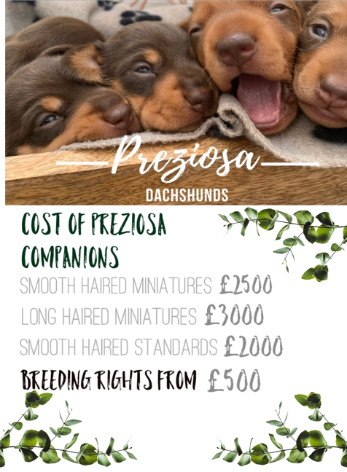

By completing and returning this questionnaire you are confirming that you understand the following:

* To reserve a Preziosa puppy you would be supplied with a copy of your contract of sale, to ensure you fully appreciate the terms and conditions of sale and the price that you were buying said puppy under.
* Once your Puppy is born - To procced you would be expected to pay a non-refundable holding fee of £300, within 48rhs or receiving the contract.
* The Holding fee is taken off of any final balance.
* The final balance of the Puppy is to be paid 48hrs prior to collection date.